1. Kode :

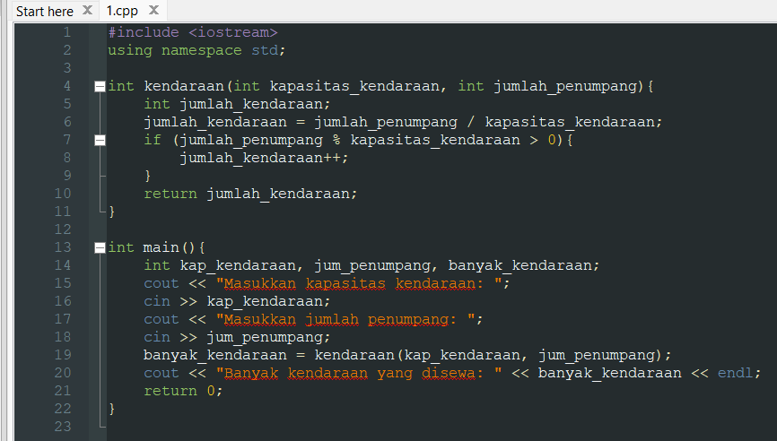  
Hasil :

1. Kode :

Hasil :

1. Kode :

Hasil :

